Exp 06: Demonstrate virtualization by Installing Type-2 Hypervisor in your device,
create and configure VM image with a Host Operating system (Either
Windows/Linux) using virtual box
Aim
To install a Type-2 hypervisor (Oracle VirtualBox), create and configure a Virtual Machine with 1 CPU, 2 GB RAM, and 15 GB storage, and install a guest operating system (Ubuntu/Windows) on the virtual machine
Procedure
- Install VirtualBox on the host machine (Windows/Linux) and ensure virtualization (Intel VT-x / AMD-V) is enabled in BIOS/UEFI.
- Launch VirtualBox and create a new Virtual Machine, specifying the OS type and version.
- Allocate hardware resources – set 2048 MB RAM and 1 CPU for the VM.
- Create a Virtual Hard Disk of 15 GB (VDI, dynamically allocated) for the VM.
- Attach the OS ISO file to the VM’s optical drive and start the VM to install the guest operating system.
- Complete OS installation and install Guest Additions to enable smooth display, clipboard sharing, and better performance.
Output
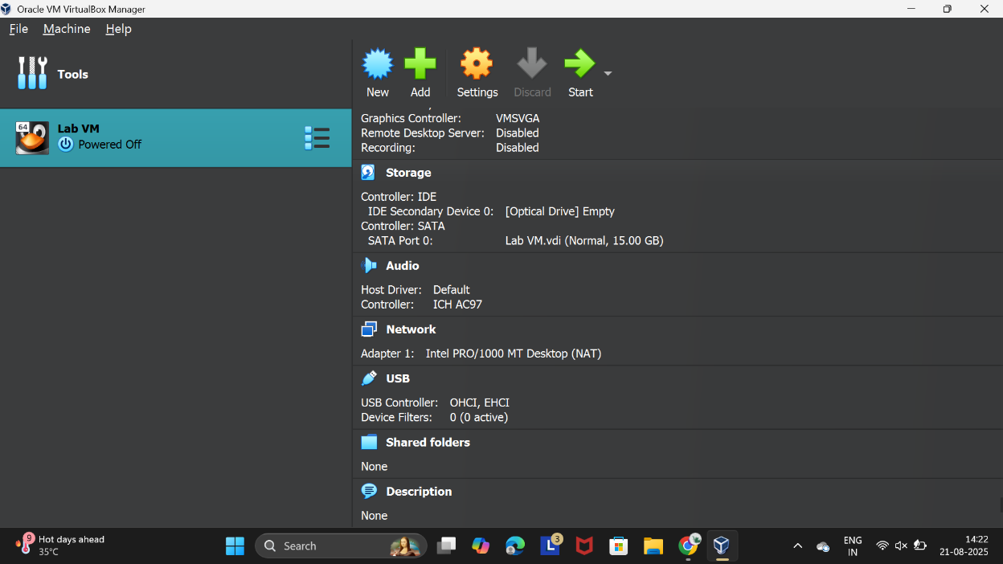
Figure 1 Virtual Machine with 1 CPU, 2 GB RAM, and 15 GB storage

Result
A Type-2 hypervisor (VirtualBox) was successfully installed on the host machine. A Virtual Machine was created with the configuration 1 CPU, 2 GB RAM, 15 GB storage, and a guest operating system (Ubuntu/Windows) was installed and executed successfully.

